Kayla Kuhn

7/19/20

Challenge 1

**Outcomes of Campaign’s Success/ Failure**

**Overview of Project:**

The purpose of this project is to figure out the relationship of different campaigns compared to Louise’s. We will be looking at the campaign launch dates and funding goals of multiple campaigns. After shifting though data, the hope is that the graphs and tables will help Louise see where she is compared to other campaigns similar to hers. Ultimately with the knowledge gain Louise will be able to make a decision on how to move forward with her campaign.

**Purpose:**

The purpose of this project is to create visuals that will help Louise make an informative decisions on what she should do with her campaign. She had fundraised a good amount what she needed, but hasn’t met her goal yet. With seeing the different outcomes she will be able to decided what are the best decisions for her campaign going forward.

**Analysis and challenges:**

Picture 1:

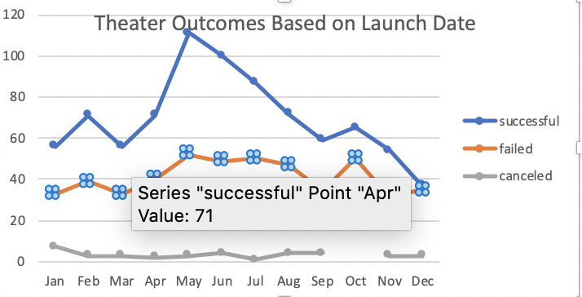

Picture 2:

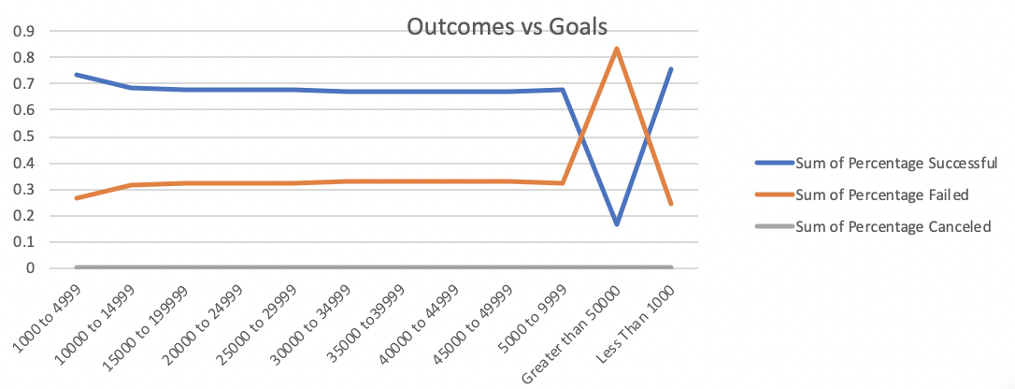

Picture 3:

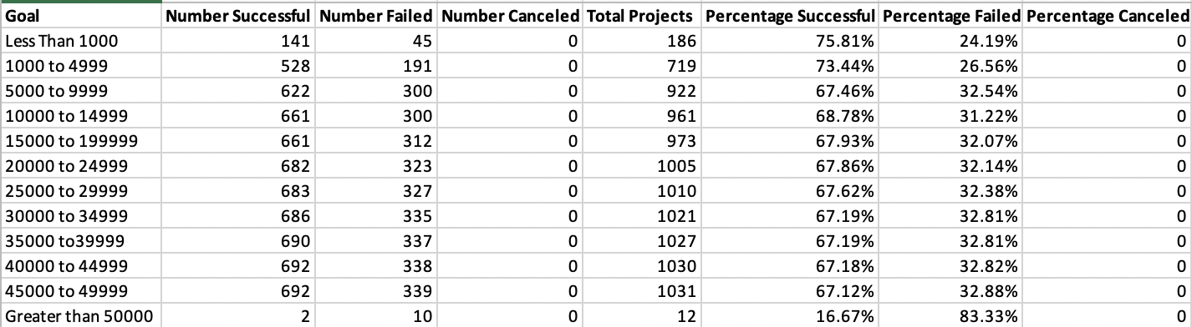

To be able to analyze the campaign launch dates and funding goals, it was easier to put them in graphs. For example in picture one you are able to see the relationship of the launch date to the play failing or not. In picture 2, you can see the relationship of the outcomes the goals. (I added picture 3 because I could not get my graph to look like the one in the module’s).

**Analysis of outcomes based on launch date:**

Refer to picture 1 when analyzing the outcomes base on launch date, you can see that May is a great time to have a play out, for both failed and successful plays. It is clear that the launch date really helps the plays that succeeded, but for the plays that fails, it didn’t matter too much when the play was launched. It does look like overall summer time is a good time to launch plays.

**Analysis of outcome based on goals**

As there is more money there is a steady increase in the percentage of failed plays. As there is more money for a successful play you see a steady decrease until 35000 to 450000 than it plummets again. For the percentage of the plays canceled you can see there is no significance in the percentage canceled.

**Challenges and difficulties encountered**

Challenges that were encountered was making sure that there were no spelling errors and to make sure to sort the right things into the pivot tables to get the right graph. As you can see picture two was not the right graph. I based my analysis off the correct graph in the modules. It is very difficult to measure for the percentage of canceled shows to show their impact on funding.

**Results**

With the launch date in mind, it is imperative to have the play launch in the summer time, preferably around May. In addition to the launch date impacting failed verses successful plays, it didn’t matter too much on when the play launched. It really depends on how good the play is. With the outcomes based on the goals, the money didn’t matter to the failure/ success of the project. You can see no matter how much money the failed or successful plays made, have a huge impact on the percentage of success or failure. Limitations of the dataset is you aren’t aware of how popular the play is. For example Hamilton is very well known play, you know it is on demand to be seen but the plays that are brand new and may not have known actors can be hard to promote for and to be successful. Other tables and graphs we should create could be based on the genre of the play, some plays are more popular than other. Another thing we should look at is how well known the actors/ how experience they are.